SECTION 08 7100

PANIC, DEADBOLT, AND ELECTRIC EGRESS HANDLES FOR ALL GLASS ENTRANCES

PART 1 - GENERAL

  - SUMMARY

- This section includes:

  - Access Control Handles for ‘all-glass’doors.

- Related work in other sections:

  - Section 08 80 00 - Glazing
  - Section 08 4210 - All Glass Entrances.
  - Section 08 8100 - Glass and Glazing.

SUBMITTALS

- Product Data: Submit Manufacturer’s product data for Access Control Handles for ‘all-glass’ entrance systems including:

  - Manufacturer’s standard details and fabrication method.
  - Data on finishes, hardware, and accessories.
  - Recommendations for maintenance and cleaning of finish surfaces.
  - Test data and UL Certificates (if applicable.)

- Shop drawings for each ‘all-glass’ entrance system with access control handles are required, including:

  - Layout and installation details.
  - Elevations at 1/4-inch scale.
  - Detail sections of fittings.
  - Hardware mounting heights.
  - Glazing details.

- Samples for approval:

  - Submit pairs of samples of each specified metal color and finish on sections of

extrusions or formed shapes.

QUALITY ASSURANCE

- Installer qualifications: Engage an experienced installer who has completed installations of ‘all-glass’ entrances with access control handles similar in design and extent to those required for the project and whose work has resulted in construction with a record of successful in service performance.

- Manufacturer’s qualifications: Provide Access Control Handles for ‘all-glass’ entrances produced by a firm experienced in manufacturing entrance systems that are similar to those indicated for this project and that have a proven record of success in service performance. All Access Control Handles must be tested.

- Single source responsibility: Obtain Access Control Handles for ‘all-glass’ entrance systems from a single manufacturer, to ensure full compatibility and warranty of parts.

- Design criteria: The drawings indicate the size, diameter, and dimensional requirements of the Access Control Handles for the ‘all-glass’ entrance system required and are based on the specific types and models indicated.

- 1/2” (12 mm) or 3/4” (19 mm) Safety glass standard: Provide tempered glass components that comply with ANSI Z97.1 and testing requirements of CPSC 16 CFR 1201

Category II. (See Section 08 81 00 Glass and Glazing as supplied by others).

- Testing criteria for Access Control Handles:
  - Panics: UL305, ULC-S132-07, and ANSI/BHMA A156.3-2008 Grade 1 Certified
  - Deadbolts: UL Classified to ANSI A156.16-1997 Standard
  - Electric Egress: UL294-2001 and ULC-S533-2002 Recognized Components, tested to NFPA 101-2002 Life and Safety Code Standards.

DELIVERY, STORAGE, AND HANDLING

- Deliver Access Control Handles and related components in the manufacturer’s original protective packaging. Do not deliver entrance units until the work is ready for their installation.

  - Inspect components for damage upon delivery. Unless minor defects in metal components can be made to meet the Architect’s specifications and satisfaction, damaged parts should be removed and replaced.

PROJECT CONDITIONS

A. Field Measurements: Check opening by accurate field measurement before fabrication. Show recorder measurements on shop drawings. Coordinate fabrication schedule with construction progress to avoid delay of the work and possible damage to the finished product.

PART 2 - PRODUCTS

  - ACCEPTABLE MANUFACTURER’S

A. Basis of design: Design is based on Access Control Handles for ‘All-Glass’ Entrances featuring heavy tempered glass as manufactured by:

CRL-Blumcraft
Tel: (800) 421-6144 Fax: (800) 587-7501
Email: architectural@crlaurence.com www.crlaurence.com
www.crl-arch.com

MATERIALS

- LEED® requirements:
  - Recycled Content Materials: Provide building materials with recycled content such that post-consumer recycled content plus one-half of pre-consumer recycled content constitutes a minimum of 20 percent of the cost of materials used for the project. See LEED® Green Building Rating System.
  - Regional Materials: Provide a minimum of 10 percent (based on cost) of building materials that are regionally extracted, processed, and manufactured.

Note: Specifier to choose one Access Control Handle from below and eliminate the remaining

Access Control handles:

  - Concealed Panic Handles: Panic device shall be 1-1/4” (32 mm) diameter
CRL-Blumcraft PA100 or PA110 with interior operating panic handle in combination with exterior fixed pull handles designated by letters. Panic mechanism shall be concealed within the brass or stainless-steel tubing and the latch bolt is retracted by pushing the interior ‘L’ shaped crash bar. Entrance from exterior by a keyed cylinder is
optional. Dogging shall be standard and conveniently located with a built-in dogging pin that keeps the latch bolt in the retracted position and the crash bar fixed.

  - Vertical Rod Device: Panic device shall be ultra-narrow crash bar.
CRL-Blumcraft PA300 Series with interior operating ultra-narrow crash bar that securely attaches to a vertical 1-1/4” diameter handle in combination with exterior fixed pull handles designated by letters. Panic mechanism shall be concealed
within the stainless-steel tubing and ultra-narrow crash bar. The latch bolt is retracted by pushing the ultra-narrow crash bar. Entrance from exterior by keyed cylinder is optional. Dogging shall be standard and conveniently located with a built-in dogging pin that keeps the latch bolt in the retracted position and the crash bar fixed.

  - California 5lb Panic Handles: Panic device shall be 1-1/4” (32 mm) diameter
CRL-Blumcraft PAC100 Series with interior operating panic handle in combination with exterior fixed pull handles designated by letters. Panic mechanism shall be concealed within the brass or stainless-steel tubing and the latch bolt is retracted by pushing the interior ‘L’ shaped crash bar. Entrance from exterior by a keyed cylinder is optional. Dogging shall be standard and conveniently located with a built-in dogging pin that keeps the latch bolt in the retracted position and the crash bar fixed.

Meets the following: CBC 11B-404.2.7 and ADA 404.2.7

  - Balance Door Panic Handles: Panic device shall be 1-1/4” (32 mm) diameter
CRL-Blumcraft BP100 Series with interior operating panic handle in combination with exterior fixed pull handles designated by letters. Panic mechanism shall be concealed within the brass or stainless-steel tubing and the latch bolt is retracted by pushing the interior ‘L’ shaped crash bar. Entrance from exterior by a keyed cylinder is optional.
Dogging shall be standard and conveniently located with a built-in dogging pin that keeps the latch bolt in the retracted position and the crash bar fixed.

Meets building code requirements for Balance Doors when code states that the push pad shall not extend more than one-half the width of the door.

  - Designer Panic Handles: Panic device shall be 1-1/4” D-Shaped
CRL-Blumcraft DP100 Series with interior operating panic handle in combination with exterior fixed pull handles designated by letters. Panic mechanism shall be concealed within the brass or stainless-steel tubing and the latch bolt is retracted by pushing the interior ‘L’ shaped crash bar. Entrance from exterior by a keyed cylinder is optional.
Dogging shall be standard and conveniently located with a built-in dogging pin that keeps the latch bolt in the retracted position and the crash bar fixed.

- Deadbolt Lock Handles: Shall be CRL-Blumcraft DB100, DB110, DB130, DB140, DB150, DB160, DB170 with interior fixed handle and any of the fixed exterior pull
handles designated by letters. Operating mechanism shall be concealed within the 1-1/4” (32 mm) brass or stainless-steel tubing. There shall be a keyed cylinder on both sides or a thumbturn on the interior side where indicated. The locking mechanism shall be on the interior side of the door.

- Electronic Egress Control Handles: Shall be CRL-Blumcraft EG100 or EG110 with interior operating egress handle in combination with exterior fixed pull handles designated by letters. Panic mechanism shall be concealed within the brass or stainless-steel tubing and the electronic switch is activate by pushing the interior ‘L’ shaped crash bar. This handle movement sends a signal to an independent electronic lock located at the header or transom bar, thus permitting exit. Releasing the crash bar signals the magnetic lock to prepare for relocking. Entrance from exterior by a keyed is cylinder optional.

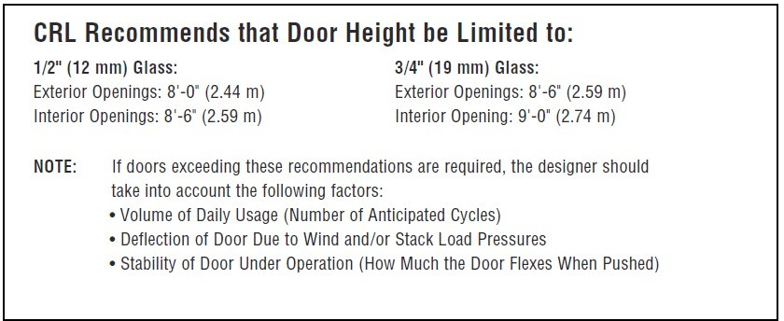

Final determination should be made by the architect’s structural engineer.

- Glass: Provide flat, fully tempered glass in thickness indicated for doors and sidelites. Comply with requirements of ASTM C 1048 for FT (fully tempered), Condition A (uncoated surfaces), Type 1 (transparent) Class 1 (clear) glass. Provide products of thickness indicated that have been tested for surface and edge compression according to ASTM C 1048 and for impact strength according to 16 CFR Part 1201 for Category II materials.

  - Thickness: 1/2 inch (12 mm)
  - Thickness; 3/4 inch (19 mm)
  - Edge treatment: Provide machine ground and polished edges for exposed glass edges of doors and sidelites and flat ground edges for butting glass edges.
  - Glass Manufacturers: .
INTERIOR DOOR HANDLES
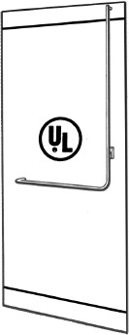
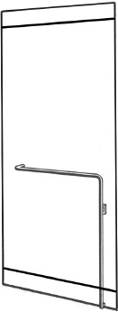
CRL Panic Handles
For 1/2” (12 mm) or 3/4” (19 mm) Tempered Glass
Can Be Used as Replacement for Older Panics
Custom Sizes of Stock Finishes Ship Within Three to Five Business Days
Optional Keyed Access
Optional Electric Strike
Optional Exterior Fixed Handles
Available in Polished or Brushed Stainless Steel, Polished or Satin Brass, and Oil Rubbed Bronze
Operating Handles on Interior Side of Door
Panic Handle Min: 33”
Max: 104-7/8”

2021 IBC: 34” - 36” AFF
2019 CBC: 34” - 44” AFF
PA100 Series
Secures at top of door
PA110 Series
Secures at bottom of door

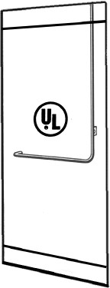
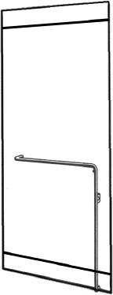
CRL Deadbolt Handles
For 1/2” (12 mm) or 3/4” (19 mm) Tempered Glass
Can Be Used as Replacement for Older Deadbolts
Custom Sizes of Stock Finishes Ship Within Three to Five Business Days
Optional Keyed Access
Optional Electric Strike
Optional Exterior Fixed Handles
Available in Polished or Brushed Stainless Steel, Polished or Satin Brass, and Oil Rubbed Bronze
Certification: ANSI/BHMA A156.16 Grade 1
With Locking Mechanism Interior Side of Door
60” Max for 1/2” (12 mm) Glass
66” Max for 3/4” (19 mm) Glass

2021 IBC: 34” - 36” AFF
2019 CBC: 34” - 44” AFF
DB100 Series
DB110 Series

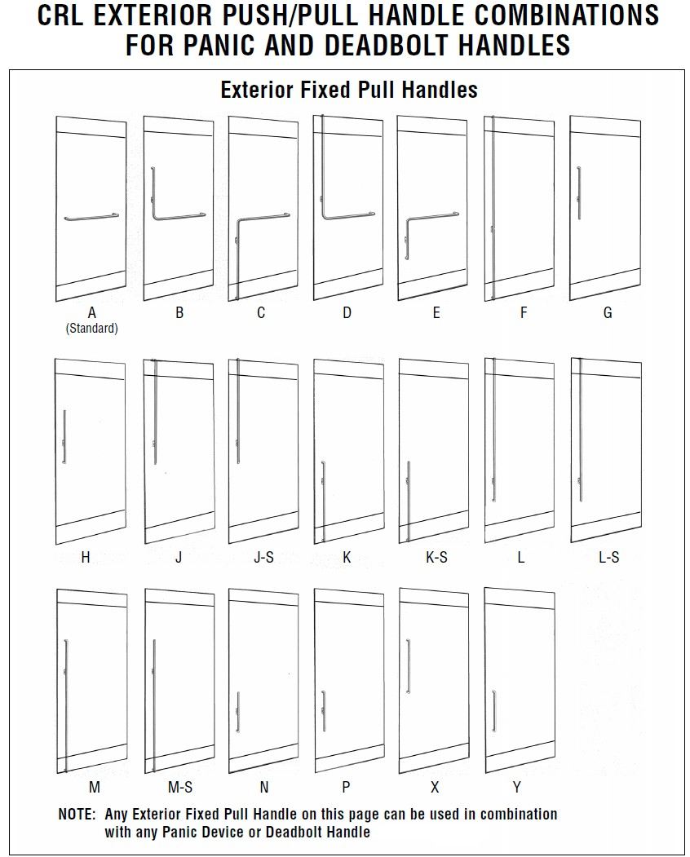
I

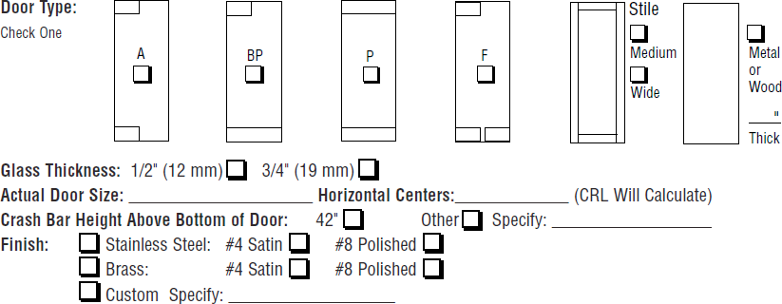

HARDWARE

- General: Provide heavy-duty hardware units as indicated, scheduled or required for operation of each type of door, including the following items of sizes, numbers, and type recommended by the manufacturer for the type of service required. Provide metal and finish for exposed parts to match the finish of the door.

- Electric Strikes: Shall be Folger Adams 310-1 with ¾” straight latch bolt keeper without signal switches using PA100 Panic Handles. Electric strikes are mounted in the header or transom bar.

- Cylinders or Magnetic Locks: Supplied as described under Division 8 section, for keying into building system.

K. Threshold: Provide manufacturer’s standard extruded aluminum threshold in mill finish. Coordinate cutouts with operating hardware. Include anchors and jamb clips.

FABRICATION

- General: Fabricate Access Control Handles for ‘all-glass’ entrance to designs and sizes indicated. Size of door and profile requirements of fittings and hardware are indicated on the drawings.

  - Locate and provide holes and cutouts in glass to receive hardware before tempering glass. Do not permit cutting, drilling or other alterations to glass after tempering.
  - Fabricate work to accommodate required fittings, hardware, anchors, reinforcement, and accessory items.

- Prefabrication: Complete fabrication, assembly, finishing, hardware application and other work to the greatest extent possible before shipment to the project site. Disassemble components only as necessary for shipment and installation.

  - METAL FINISHES: (Specify finish)

A. Brushed Stainless Steel Polished Stainless Steel Satin Brass
Polished Brass
Oil Rubbed Bronze
Other Custom Metal and Powder Coat finishes available (Architect to Specify)

PART 3 - EXECUTION

  - EXAMINATION

- Examine handle with the installer, present for compliance with requirements indicated, installation tolerances and other conditions that affect the installation of the ‘all-glass’ entrances and storefronts. Correct unsatisfactory conditions before proceeding with the installation.

  - Do not proceed with installation until unsatisfactory conditions are corrected.

INSTALLATION

- Install access control handles and associated components in accordance with manufacturer’s printed instructions and recommendations.

  - Lubricate hardware and other moving parts.

ADJUSTING

- Adjust doors and hardware to provide a smooth operation at latching points for a secure, tight closure.

- Hardware: Adjust operating hardware to ensure proper operation. Set, seal, and grout floor closer cases. Coordinate cylinder installation.

CLEANING

- Clean handle, door, and frame surfaces after installation, exercising care to avoid damage to the finish.

- Clean glass surfaces after installation, complying with requirements contained in the “Glass and Glazing” section for cleaning and maintenance. Remove excess glazing sealant compounds, dirt or other substances.

PROTECTION

A. Institute protective measures required throughout the remainder of the construction period to ensure that the ‘all-glass’ entrances do not incur any damage or deterioration, other than normal weathering, at the time of acceptance.

-END OF SECTION-

